**Step #1) Purpose of the document**

**Final report of Testing**

This document explains the various activities performed as part of the Testing of the ‘irctc Registration’ application.

**Step #2) Application Overview**

**<Brief description of the application tested>**

‘irctc Registration’ is a web-based flight booking application. There is a modules like Registration, Login , Holidays, which are integrated to fulfil the purpose.

**Step #3) Testing Scope**

1. In Scope
2. Out of Scope
3. Items not tested

**<This section explains the functions/modules in scope & out of scope for testing; Any items which are not tested due to any constraints/dependencies/restrictions>**

A functionality verification that needs connectivity to a third party application cannot be tested, as the connectivity could not be established due to some technical limitations. This section should be clearly documented, else it will be assumed that Testing covered all areas of the application.

* **In-Scope:**Functional Testing for the following modules are in Scope of Testing
  + Registration
* **Out of Scope:**Performance Testing was not done for this application.
* **Items not tested:**Verification of connectivity with the third party system ‘Central repository system’ was not tested, as the connectivity could not be established due to some technical limitations. This can be verified during UAT (User Acceptance Testing) where the connectivity is available or can be established.

**Step #4) Metrics**

**<Metrics will help to understand the test execution results, the status of test cases & defects, etc. Required Metrics can be added as necessary. Example: Defect Summary-Severity wise; Defect Distribution-Function/Module wise; Defect Ageing etc.. Charts/Graphs can be attached for better visual representation>**

* **No. of test cases planned vs executed**
* **No. of test cases passed/failed**

|  |  |  |  |
| --- | --- | --- | --- |
| Total Test Case | Test cases executed | Test case passed | Test case failed |
| 100% | 100% | 93% | 7% |

[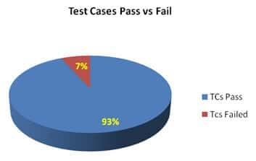](https://cdn.softwaretestinghelp.com/wp-content/qa/uploads/2014/06/test-summary-report-2.jpg)

* **No of defects identified and their Status & Severity**

[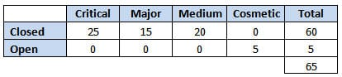](https://cdn.softwaretestinghelp.com/wp-content/qa/uploads/2014/06/test-summary-report-3.jpg)

[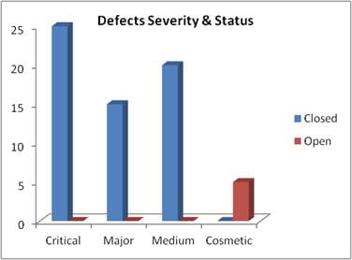](https://cdn.softwaretestinghelp.com/wp-content/qa/uploads/2014/06/test-summary-report-4.jpg)

**Step #5) Types of testing performed**

1. Smoke Testing
2. System Integration Testing
3. [and Regression Testing](https://www.softwaretestinghelp.com/regression-testing-tools-and-methods/)

**<Describe the various types of Testing performed for the Project. This will make sure the application is being tested properly through testing types agreed as per Test Strategy.**

**Note: If several rounds of testing were done, the details can also be included here.>**

**a) Smoke Testing**  
This testing was done whenever a Build is received *(deployed into Test environment)* for Testing to make sure the major functionality is working fine, Build can be accepted and Testing can start.

**b) System Integration Testing**

* This is the Testing performed on the Application under test, to verify the entire application works as per the requirements.
* Critical Business scenarios were tested to make sure important functionality in the application works as intended without any errors.

**c) Regression Testing**

* Regression testing was performed each time a new build is deployed for testing which contains defect fixes and new enhancements if any.
* Regression Testing is being done on the entire application and not just the new functionality and Defect fixes.
* This testing ensures that existing functionality works fine after defect fix and new enhancements are added to the existing application.
* Test cases for new functionality are added to the existing test cases and executed.

**Step #6)**[**Test Environment & Tools**](https://www.softwaretestinghelp.com/test-bed-test-environment-management-best-practices/)

**<Provide details on Test Environment in which the Testing is carried out. Server, Database, Application URL, etc. If any Tools were used like Quality Center (now HP ALM) for logging defects>**

|  |  |
| --- | --- |
| **Application Url** | https://www.irctc.co.in/nget/profile/user-registration |
| **Tools Used** | Selenium Webdriver, TestNG, POI, Extent Report |
|  | Excel |
|  |  |

**Step #7) Lessons Learned**

**<This section is used to describe the critical issues faced and their solutions (how they were solved during the Testing). Lessons learned will help to make proactive decisions during the next Testing engagement, by avoiding these mistakes or finding a suitable workaround>**

[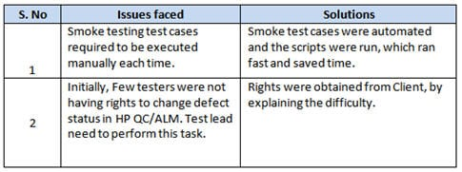](https://cdn.softwaretestinghelp.com/wp-content/qa/uploads/2014/06/test-summary-report-8.jpg)

**Step #8) Recommendations**

**<Any workaround or suggestions can be mentioned here>**

* Admin control for defect management tools can be given to Offshore Test manager for providing access to the Testing team.
* Each time the onsite Admin need not be contacted for requests whenever they arise, thereby saving time due to the geographical time zone difference.

**Step #9) Best Practices**

**<There will be a lot of activities done by the Testing team during the project. Some of them could have saved time, some proved to be a good & efficient way to work, etc. These can be documented as a ‘Value Add’ to showcase to the Stakeholders>**

* A repetitive task done manually every time was time-consuming. This task was automated by creating scripts and run each time, which saved time and resources.
* Smoke test cases were automated and the scripts were run, which ran fast and saved time.
* Automation scripts were prepared to create new customers, where a lot of records need to be created for Testing.
* Business-critical scenarios are separately tested on the entire application which is vital to certify they work fine.

**Step #10) Exit Criteria**

**<Exit Criteria is defined as a Completion of Testing by fulfilling certain conditions like  
(i) All planned test cases are executed;**  
**(iI) All Critical defects are Closed etc.>**

* All test cases should be executed – **Yes**
* All defects in Critical, Major, Medium severity should be verified and closed – **Yes**.
* Any open defects in Trivial severity – **Action plan prepared with expected dates of closure.**

No Severity1 defects should be ‘OPEN’; Only 2 Severity2 defects should be ‘OPEN’; Only 4 Severity3 defects should be ‘OPEN’. Note: This may vary from project to project. Plan of Action for the Open defects should be clearly mentioned with details on when & how they will be addressed and closed.>

**Step #11) Conclusion/Sign Off**

***<This section will mention whether the Testing team agrees and gives a Green signal for the application to ‘Go Live’ or not after the Exit Criteria was met. If the application does not meet the Exit Criteria, then it can be mentioned as – “The application is not suggested to ‘Go Live’. It will be left with the decision of Senior Management and Client and other Stakeholders involved to take the call on whether the application can ‘Go Live’ or not.>***

As the Exit criteria were met and satisfied as mentioned in Section 10, this application is suggested to ‘Go Live’ by the Testing team. Appropriate User/Business acceptance testing should be performed before ‘Go Live’.

**Step #12) Definitions, Acronyms, and Abbreviations**